**Lab: For Loop**

Problems for exercise and homework for the "**Programming Basics**" course [@ SoftUni Global](https://softuni.org).

Submit your solutions in the SoftUni Judge system at: <https://judge.softuni.org/Contests/Compete/Index/3546>

## Numbers from 1 to 100

Write a program that prints the numbers from 1 to 100, each on a new line.

### Sample Input and Output

|  |  |
| --- | --- |
| **Input** | **Output** |
| (no input) | 1  2  3  …  98  99  100 |

### Hints and Guidelines

1. Create a **for** loop with an initial value of the control variable **i = 1**. Make the end value less than or equal to **100**. In the block of the cycle code, print **i**:

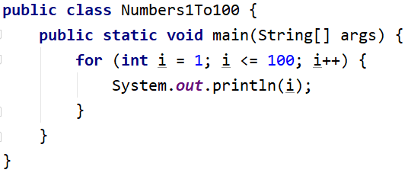

1. Start the program with[Ctrl+Shift+F10] and test it:

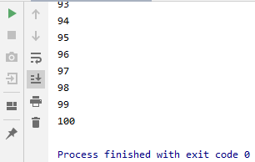

### Testing in the Judge System

Test the solution to this problem here: <https://judge.softuni.org/Contests/Compete/Index/3546#0>

## Numbers N...1

Write a program that reads a positive integer **n** entered by the user and prints the numbers from **n** to **1** in reverse order. The number **n** entered will always be greater than 1.

### Sample Input and Output

|  |  |  |  |  |  |  |  |
| --- | --- | --- | --- | --- | --- | --- | --- |
| **Input** | **Output** |  | **Input** | **Output** |  | **Input** | **Output** |
| 2 | 2  1 | 3 | 3  2  1 | 5 | 5  4  3  2  1 |

### Hints and Guidelines

1. Read an integer from the console:

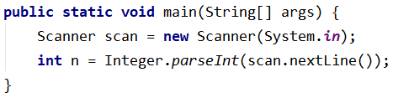

1. Create one **for loop** from **n** to **0**, but instead of increasing the variable i by 1, **decrease it by 1 for each iteration of the loop**:

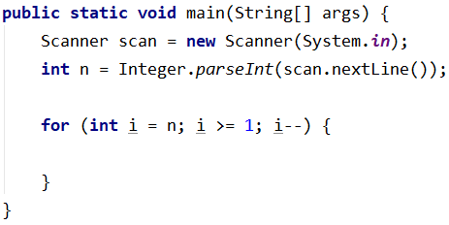

1. Print the variable **i** in the body of the loop:

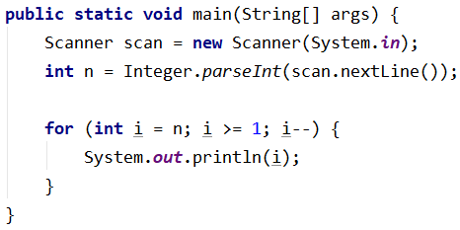

### Testing in the Judge System

Test the solution to this problem here: <https://judge.softuni.org/Contests/Compete/Index/3546#1>

## Numbers 1...N with Step 3

Write a program that reads the number **n** entered by the user and prints the **numbers from 1 to n through 3.**

### Sample Input and Output

|  |  |  |  |  |  |  |  |
| --- | --- | --- | --- | --- | --- | --- | --- |
| **Input** | **Output** |  | **Input** | **Output** |  | **Input** | **Output** |
| 10 | 1  4  7  10 | 7 | 1  4  7 | 15 | 1  4  7  10  13 |

### Hints and Guidelines

1. Read an integer **n** from the console:



1. Write a **for loop** **from 1 to n (inclusive) and set the step to 3**. This means that with each iteration of the loop, the variable i **will increase its value by 3 instead of 1:**

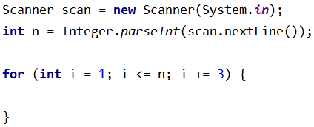

1. Print the variable **i** in the body of the loop:

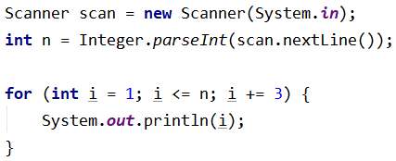

### Testing in the Judge System

Test the solution to this problem here: <https://judge.softuni.org/Contests/Compete/Index/3546#2>

## Even Powers of 2

Write a program that reads the number **n** entered by the user and prints the even power of **2** **≤** **2n**: **20**, **22**, **24**, **26**, …, **2n**.

### Sample Input and Output

|  |  |  |  |  |  |  |  |  |  |  |  |  |  |
| --- | --- | --- | --- | --- | --- | --- | --- | --- | --- | --- | --- | --- | --- |
| **Input** | **Output** |  | **Input** | **Output** |  | **Input** | **Output** |  | **Input** | **Output** |  | **Input** | **Output** |
| 3 | 1  4 | 4 | 1  4  16 | 5 | 1  4  16 | 6 | 1  4  16  64 | 7 | 1  4  16  64 |

### Testing in the Judge System

Test the solution to this problem here: <https://judge.softuni.org/Contests/Compete/Index/3546#3>

## Character Sequence

Write a program that reads text (string) entered by the user and prints each character of the text on a separate line.

### Sample Input and Output

|  |  |  |  |
| --- | --- | --- | --- |
| **Input** | **Output** | **Input** | **Output** |
| softuni | s  o  f  t  u  n  i | ice cream | i  c  e    c  r  e  a  m |

### Hints and Guidelines

1. Read the input text:

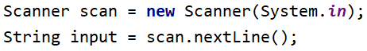

1. Write a **for loop** with an initial value of the control variable from **0** to **input.length()**. On each iteration, take the letter at the position in the entered word equal to the value of the control variable **i**, using the method **charAt()**

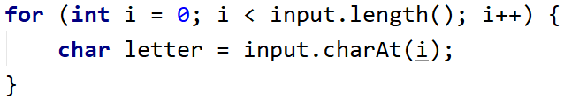

1. At each iteration, print the value of the variable **letter**:

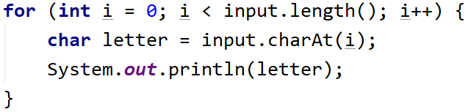  
Testing in the Judge System

Test the solution to this problem here: <https://judge.softuni.org/Contests/Compete/Index/3546#4>

## Vowels Sum

Write a program that reads **text** (string) entered by the user, calculates, and prints the **sum of the values of the vowels** according to the table below:

|  |  |  |  |  |  |
| --- | --- | --- | --- | --- | --- |
| letter | a | e | i | o | u |
| value | 1 | 2 | 3 | 4 | 5 |

### Sample Input and Output

|  |  |  |
| --- | --- | --- |
| **Input** | **Output** | **Comments** |
| hello | 6 | e + o = 2 + 4 = 6 |
| hi | 3 | i = 3 |
| bamboo | 9 | a + o + o = 1 + 4 + 4 = 9 |
| beer | 4 | e + e = 2 + 2 = 4 |

### Testing in the Judge System

Test the solution to this problem here: <https://judge.softuni.org/Contests/Compete/Index/3546#5>

## Sum Numbers

Write a program that reads **n-number integers** entered by the user and sums them.

* On the first line, print the number n that you will enter.
* On the next lines, enter the **n numbers** that you will sum.

The program must read the numbers, sum them, and print their sum.

### Sample Input and Output

|  |  |  |  |  |  |  |  |  |  |  |  |  |  |
| --- | --- | --- | --- | --- | --- | --- | --- | --- | --- | --- | --- | --- | --- |
| **Input** | **Output** |  | **Input** | **Output** |  | **Input** | **Output** |  | **Input** | **Output** |  | **Input** | **Output** |
| 2  10  20 | 30 | 3  -10  -20  -30 | -60 | 4  45  -20  7  11 | 43 | 1  999 | 999 | 0 | 0 |

### Testing in the Judge System

Test the solution to this problem here: <https://judge.softuni.org/Contests/Compete/Index/3546#6>

## Number sequence

Write a program that reads **n integers**. Print the **largest** and **smallest** numbers from the entered numbers.

### Sample Input and Output

|  |  |  |  |  |
| --- | --- | --- | --- | --- |
| **Input** | **Output** |  | **Input** | **Output** |
| 5  10  20  304  0  50 | Max number: 304  Min number: 0 | 6  250  5  2  0  100  1000 | Max number: 1000  Min number: 0 |

### Testing in the Judge System

Test the solution to this problem here: <https://judge.softuni.org/Contests/Compete/Index/3546#7>

## Left and Right Sum

Write a program that reads **2 * n** numbers of integers submitted by the user and checks if the sum of the **first n numbers** (left sum) is equal to the sum of the **second n numbers** (right sum). In the case of equality, print "**Yes, sum =** " + **the amount**; otherwise print "**No, diff** = " + **the difference**. The difference is calculated as a positive number (use absolute value).

### Sample Input and Output

|  |  |  |  |  |  |  |
| --- | --- | --- | --- | --- | --- | --- |
| **Input** | **Output** | **Comments** |  | **Input** | **Output** | **Comments** |
| 2  10  90  60  40 | Yes, sum = 100 | 10+90 = 60+40 = 100 | 2  90  9  50  50 | No, diff = 1 | 90+9 ≠ 50+50  Difference = |99-100| = 1 |

### Testing in the Judge System

Test the solution to this problem here: <https://judge.softuni.org/Contests/Compete/Index/3546#8>

## Odd Even Sum

Write a program that reads **n-number integers** submitted by the user and checks if the **sum of the numbers of even positions** is equal to the **sum of the numbers of odd positions**.

* If the amounts are equal, print two lines: "Yes" and a new line "Sum = " + **the amount**
* If the amounts are not equal, print two lines: "No" and a new line "Diff = " + **the difference**

The difference is calculated as **absolute value**.

### Sample Input and Output

|  |  |  |  |  |  |  |  |  |  |  |
| --- | --- | --- | --- | --- | --- | --- | --- | --- | --- | --- |
| **Input** | **Output** | **Comments** |  | **Input** | **Output** | **Comments** |  | **Input** | **Output** | **Comments** |
| 4  10  50  60  20 | Yes  Sum = 70 | 10+60 = 50+20 = 70 | 4  3  5  1  -2 | No  Diff = 1 | 3+1 ≠ 5-2  Diff = |4-3| = 1 | 3  5  8  1 | No  Diff = 2 | 5+1 ≠ 8  Diff = |6-8| = 2 |

### Testing in the Judge System

Test the solution to this problem here: <https://judge.softuni.org/Contests/Compete/Index/3546#9>